1. /* INSERT AN ELEMENT IN THE GIVEN INDEX Of an array */

#include <stdio.h>

#include <stdlib.h>

int main()

{

int i, n, p, m, temp;

printf("enter the size of the array: ");

scanf("%d", &n);

int a[n + 1];

printf("\n Enter the elements of the array: ");

for(i = 0; i < n; i++)

scanf("%d", &a[i]);

printf("\n Enter the number to be inserted and the index of the position: ");

scanf("%d%d", &m, &p);

if( p >= 0 && p <= n)

{

for(i = p; i < n + 1; i++)

{

temp = a[i];

a[i] = m;

m = temp;

}

printf("\n the modified array is: ");

for(i = 0; i < n + 1; i++)

printf("%d ", a[i]);

printf("\n");

}

else

printf("Wrong input provided, kindly recheck the input and try again \n");

return 0;

}

**OUTPUT:**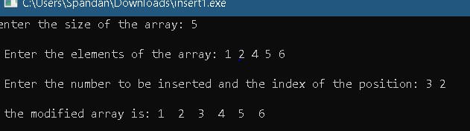

**2**. /* INSERT AN ELEMENT BEFORE THE GIVEN INDEX Of an array */  
#include <stdio.h>  
#include <stdlib.h>  
int main()  
{  
 int i, n, p, m, temp;  
 printf("enter the size of the array: ");  
 scanf("%d", &n);  
 int a[n + 1];  
 printf("\n Enter the elements of the array: ");  
 for(i = 0; i < n; i++)  
 scanf("%d", &a[i]);  
 printf("\n Enter the number to be inserted and the index of the position(the number will be inserted before the given index): ");  
 scanf("%d%d", &m, &p);  
 if((p - 1) <= n && (p - 1) >= 0)  
 {  
 for(i = p - 1; i < n + 1; i++)  
 {  
 temp = a[i];  
 a[i] = m;  
 m = temp;  
 }  
 printf("\n the modified array is: ");  
 for(i = 0; i < n + 1; i++)  
 printf("%d ", a[i]);  
 printf("\n");  
}  
else  
 printf("Incorrect index position provided, kindly check the input and try again \n");  
 return 0;  
}

**OUTPUT:** 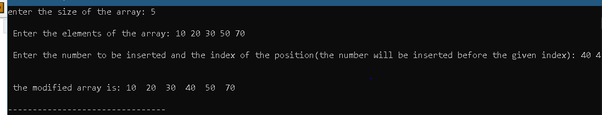  
  
  
**3.** /* INSERT AN ELEMENT AFTER THE GIVEN INDEX Of an array */  
#include <stdio.h>  
#include <stdlib.h>  
int main()  
{  
 int i, n, p, m, temp;  
 printf("enter the size of the array: ");  
 scanf("%d", &n);  
 int a[n + 1];  
 printf("\n Enter the elements of the array: ");  
 for(i = 0; i < n; i++)  
 scanf("%d", &a[i]);  
 printf("\n Enter the number to be inserted and the index of the position (the number will be inserted after the given index): ");  
 scanf("%d%d", &m, &p);  
 if((p + 1) <= n && (p + 1) >= 0)  
 {  
 for(i = p + 1; i < n + 1; i++)  
 {   
 temp = a[i];  
 a[i] = m;  
 m = temp;  
 }  
 printf("\n the modified array is: ");  
 for(i = 0; i < n + 1; i++)  
 printf("%d ", a[i]);  
 printf("\n");  
  
 }  
 else  
 printf(" the value of the position is incorrect, kindly recheck it \n");  
 return 0;  
}

**OUTPUT:** 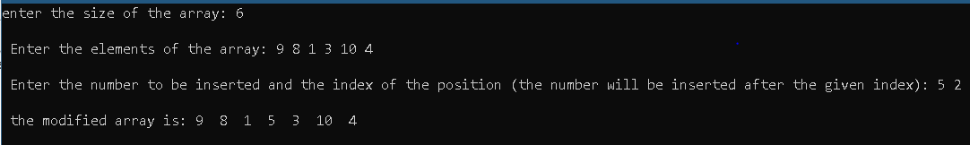

**4.** /* DELETE AN ELEMENT FROM THE GIVEN INDEX OF AN ARRAY */  
#include <stdio.h>  
#include <stdlib.h>  
int main()  
{  
 int i, n, p;  
 printf("Enter the size of the array: ");  
 scanf("%d", &n);  
 int a[n];  
 printf("\n Enter the elements of the array: ");  
 for(i = 0; i < n; i++)  
 scanf("%d", &a[i]);  
 printf("\n Enter the index which is to be deleted: ");  
 scanf("%d", &p);  
 if(p >= 0 && p < n)  
 {  
 for(i = p; i < n; i++)  
 a[i] = a[i + 1];  
 printf("\n the modified array is: ");  
 for(i = 0; i < n-1; i++)  
 printf("%d ", a[i]);  
 printf("\n");  
 }  
 else  
 printf("\n WRONG Input provided, kindly recheck the input provided ");  
 return 0;  
}  
**OUTPUT:**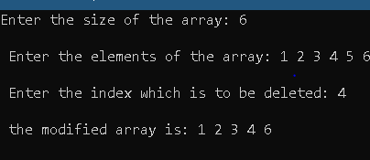

**5.** /* DELETE AN ELEMENT AFTER THE GIVEN INDEX OF AN ARRAY */  
#include <stdio.h>  
#include <stdlib.h>  
int main()  
{  
 int i, n, p;  
 printf("Enter the size of the array: ");  
 scanf("%d", &n);  
 int a[n];  
 printf("\n Enter the elements of the array: ");  
 for(i = 0; i < n; i++)  
 scanf("%d", &a[i]);  
 printf("\n Enter the index which is to be deleted: ");

scanf("%d", &p);  
 if(p + 1 >= 0 && p + 1 < n)  
 {  
 for(i = p + 1; i < n; i++)  
 a[i] = a[i + 1];  
 printf("\n the modified array is: ");  
 for(i = 0; i < n-1; i++)  
 printf("%d ", a[i]);  
 printf("\n");  
 }  
 else  
 printf("\n WRONG Input provided, kindly recheck the input provided \n");  
 return 0;  
}

**OUTPUT:** 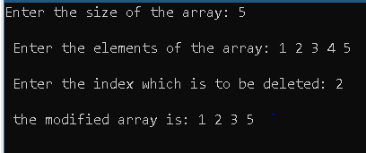

**NAME – SPANDAN CHAUDHURY**

**ROLL – 02**

**SECTION – CSE C(2)**

**SIC – 190310410**

1. /* DELETE A PARTICULAR ELEMENT FROM AN ARRAY */  
   #include <stdio.h>  
   #include <stdlib.h>  
   int main()  
   {  
    int i, n, p;  
    printf("Enter the size of the array: ");  
    scanf("%d", &n);  
    int a[n];  
    printf("\n Enter the elements of the array: ");  
    for(i = 0; i < n; i++)  
    scanf("%d", &a[i]);  
    printf("\n Enter the number to be deleted: ");  
    scanf("%d", &p);  
    for(i = 0; i < n; i++)  
    if(a[i] == p)  
    break;  
    if(i != n)  
    {  
    for(; i < n; i++)  
    a[i] = a[i + 1];  
    printf("\n the modified array is: ");  
    for(i = 0; i < n -1; i++)  
    printf("%d ", a[i]);  
    printf("\n");  
    }  
     
    else  
    printf("\n The given number is not present in the entered array! \n");  
    return 0;  
   }
2. /* DELETE AN ELEMENT BEFORE THE GIVEN INDEX OF AN ARRAY */  
   #include <stdio.h>  
   #include <stdlib.h>  
   int main()  
   {  
    int i, n, p;  
    printf("Enter the size of the array: ");  
    scanf("%d", &n);  
    int a[n];  
    printf("\n Enter the elements of the array: ");  
    for(i = 0; i < n; i++)  
    scanf("%d", &a[i]);  
    printf("\n Enter the index which is to be deleted: ");  
    scanf("%d", &p);  
    if(p - 1 >= 0 && p - 1 < n)  
    {  
    for(i = p - 1; i < n; i++)  
    a[i] = a[i + 1];  
    printf("\n the modified array is: ");  
    for(i = 0; i < n-1; i++)  
    printf("%d ", a[i]);  
    printf("\n");  
    }  
    else  
    printf("\n WRONG Input provided, kindly recheck the input provided \n");  
    return 0;  
   }

**OUTPUT:** 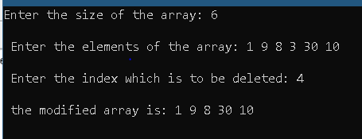

1. /* DELETE THE PREVIOUS NUMBER OF THE GIVEN PARTICULAR ELEMENT FROM AN ARRAY */  
   #include <stdio.h>  
   #include <stdlib.h>  
   int main()  
   {  
    int i, n, p;  
    printf("Enter the size of the array: ");  
    scanf("%d", &n);  
    int a[n];  
    printf("\n Enter the elements of the array: ");  
    for(i = 0; i < n; i++)  
    scanf("%d", &a[i]);  
    printf("\n Enter the number( THE ELEMENT BEFORE THE GIVEN NUMBER WILL BE DELETED): ");  
    scanf("%d", &p);  
    for(i = 0; i < n; i++)  
    if(a[i] == p)  
    break;  
    if (i == 0)  
    {  
    printf("\n Since its the first element of the array, and there is no element before that, therefore no deletion occurs: ");  
    for(i = 0; i < n; i++)  
    printf("%d ", a[i]);  
    }  
    else if(i != n)  
    {  
    for(i = i - 1; i < n; i++)  
    a[i] = a[i + 1];  
    printf("\n the modified array is: ");  
    for(i = 0; i < n -1; i++)  
    printf("%d ", a[i]);  
    }  
    else  
    printf("\n The given number is not present in the entered array! \n");  
    printf("\n");  
    return 0;  
   }
2. /* DELETE THE NEXT NUMBER OF THE GIVEN PARTICULAR ELEMENT FROM AN ARRAY */  
   #include <stdio.h>  
   #include <stdlib.h>  
   int main()  
   {  
    int i, n, p;  
    printf("Enter the size of the array: ");  
    scanf("%d", &n);  
    int a[n];  
    printf("\n Enter the elements of the array: ");  
    for(i = 0; i < n; i++)  
    scanf("%d", &a[i]);  
    printf("\n Enter the number( THE ELEMENT BEFORE THE GIVEN NUMBER WILL BE DELETED): ");  
    scanf("%d", &p);  
    for(i = 0; i < n; i++)  
    if(a[i] == p)  
    break;  
    if (i == n - 1)  
    {  
    printf("\n Since its the last element of the array, and there is no element after that, therefore no deletion occurs: ");  
    for(i = 0; i < n; i++)  
    printf("%d ", a[i]);  
    }  
    else if(i != n)  
    {  
    for(i = i + 1; i < n; i++) a[i] = a[i + 1];  
    printf("\n the modified array is: ");  
    for(i = 0; i < n -1; i++)  
    printf("%d ", a[i]);  
    }  
    else  
    printf("\n The given number is not present in the entered array! \n");  
    printf("\n");  
    return 0;  
   }
3. // DELETE ALL THE OCCURENCES OF THE GIVEN NUMBER FROM THE ARRAY.  
   #include <stdio.h>  
   #include <stdlib.h>  
   int main()  
   {  
    int n, i, j, k, count = 0;  
    printf("\n Enter the number of elements : ");  
    scanf("%d", &n);  
    int a[n];  
    printf("\n enter the elements of the array: ");  
    for(i = 0; i < n; i++)  
    scanf("%d", &a[i]);   
    printf("\n Enter the element to be deleted: ");  
    scanf("%d", &k);  
    for(i = 0; i < n; i++)  
    if(a[i] == k)  
    {  
    count++;  
    for(j = i; j < n; j++)  
    a[j] = a[j + 1];  
    i--;  
    }  
    printf("\n array after removing all occurences: ");  
    for(i = 0; i < n - count; i++)  
    printf("%d ", a[i]);  
    return 0;  
   }

**OUTPUT:** 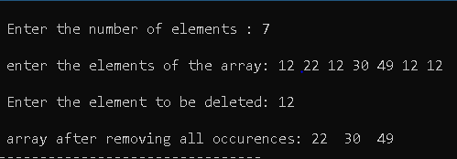

**NAME - SPANDAN CHAUDHURY** **CSE C2** **ROLL - 02** **SIC - 190310410**

1. de Open with



1.insert3.c

Open with



insert2.c

Open with

